|  |
| --- |
| **2021**  **E-Project**  [Kitchen-Ware]  Aptech Computer Education |
| TASHA KITCHEN-WARE  **Submitted By**  Ammarah Asif  Hiba Adnan  **Project Instructor**  Sir Talha Qureshi  **Submitted To**  [eprojects@aptech.ac.in](mailto:eprojects@aptech.ac.in)  **Curriculum Code**  6740 |



Content

Table of Content **Error! Bookmark not defined.**

Project Certification **Error! Bookmark not defined.**

ACKNOWLEDGMENT **Error! Bookmark not defined.**

INTRODUCTION TO “Kitchen-Ware” **Error! Bookmark not defined.**

PROBLEM STATEMENT: 5

Project Certification

**This is to certify that,**

**Ms.**

**Ammarah Asif, Enrollment no.1320093**

**Hiba Adnan, Enrollment no.1320091**

**Has successfully Designed & Developed:**

**KITCHEN-WARE**

**Submitted by: Ammarah Asif and Hiba Adnan.**

**Date of Issue: 18-Nov-2021**

Acknowledgement

I am thankful to almighty, **ALLAH** with his grace and mercy for giving me strength and ability to make me complete this e-Project website. I hereby presenting project on **Tasha Kitchen-Ware**your hands. I have tried my best to take all relevant and important topics in consideration so that this project may become more effective& a better outlook to come. This project has been developed with the help of ***“* HTML /CSS / Java Script/jQuery/Bootstrap*”***.

I earnestly hope that this project will provide all the necessary information required for the user to fulfill their requirement. However, suggestions for improvement of the project will be thankfully acknowledge.

**THANK YOU**

Welcome To

Tasha Kitchen-Ware

**Problem Statement**

**TASHA**- the home store is Branded Company famous for home kitchen appliances. It provides collection of n number of appliances with different category to match the fast life of the generation. The Tasha group of companies had made huge profit in the year 2013. In order to enhance its business the organization wants you to develop the website.

Requirement Specification:

The Web site is to be created based on the following requirements.

1) The Home page must include images with slide show and links for navigation.

2) Proper template must be designed for the website, few section of the webpage can be included to show or advertise the upcoming products.

3) Categories like Cookware, Refrigeration, Appliances, food storage, Knives and tools, Laundry and other accessories

4) List such as:

- Cookware:

i. Cooking pots

ii. Cooking Pans

iii. Frying Pans

iv. Cookware Sets

v. Handis

vi. Kadais [Karahi]

vii. Grill pans

viii. Tawas

ix. Egg Poachers

x. Steamers

- Refrigeration

i. Freezers

ii. Refrigerators

- Appliances

i. Blenders

ii. Bread Makers

iii. Coffee Makers

iv. Ice-Cream and sorbet makers

v. Electric Kettles

vi. Food Choppers

vii. Toasters

- Food Storage

i. Flask

ii. Spice Jars

iii. Storage Bags

iv. Lunch Boxes

v. Vacuum bottles. And so on

5) Support Link can be added for proving aid services such as

- Manuals

- Expert Tips

- Register Complain

- Feedback

- Contact

6) Store Locators: must display the address location of all the branches available.

7) Navigation of the project must be made precise and uniformity must be maintained.

**Home**

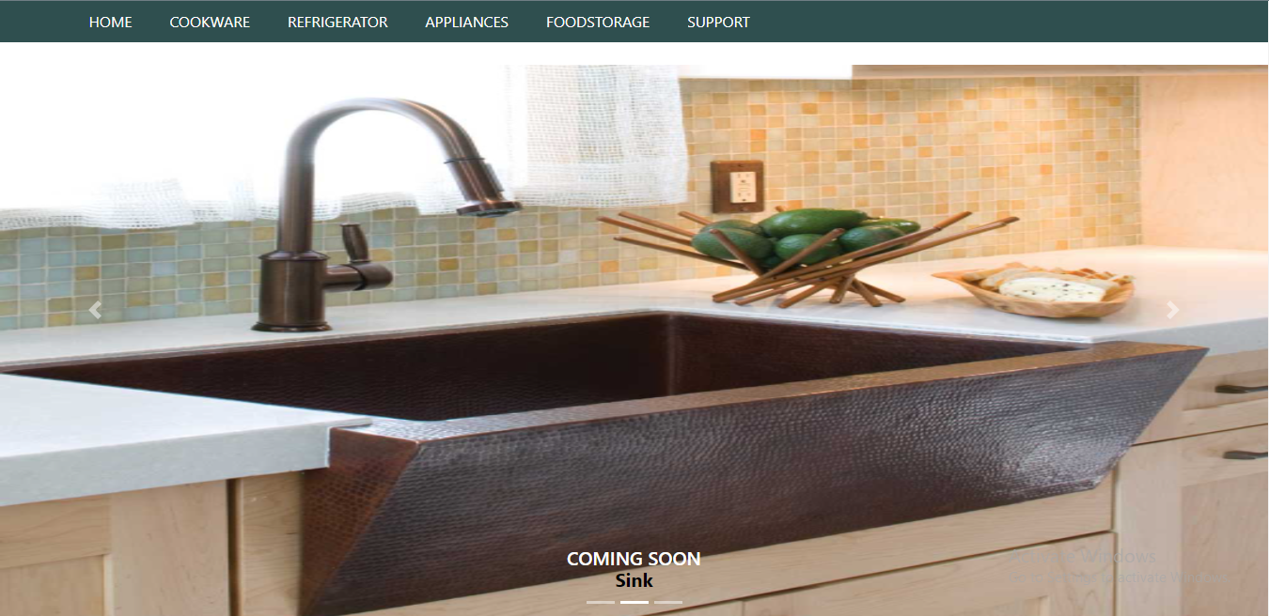

Home

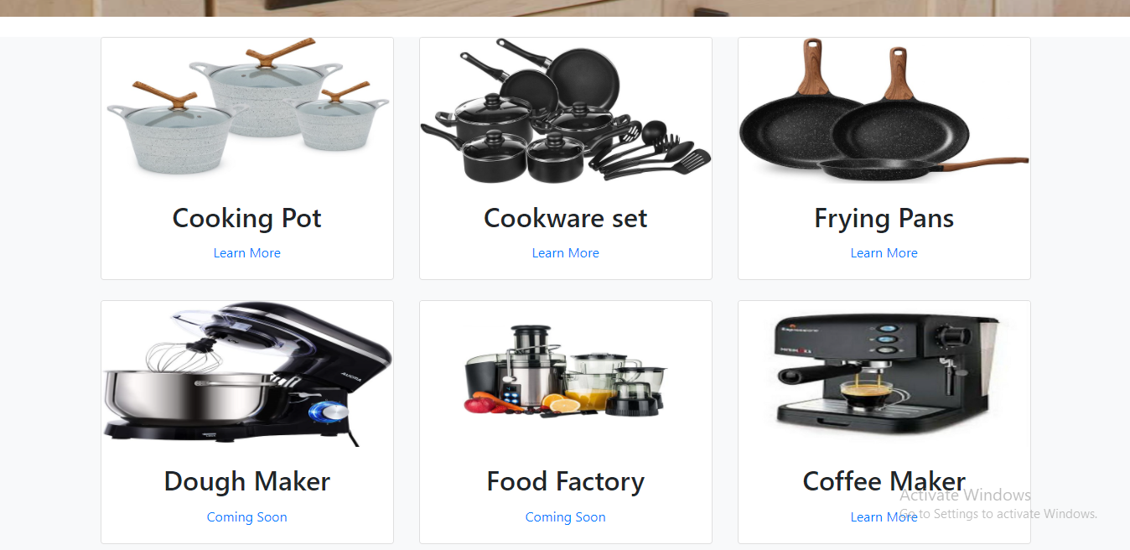

**Home**

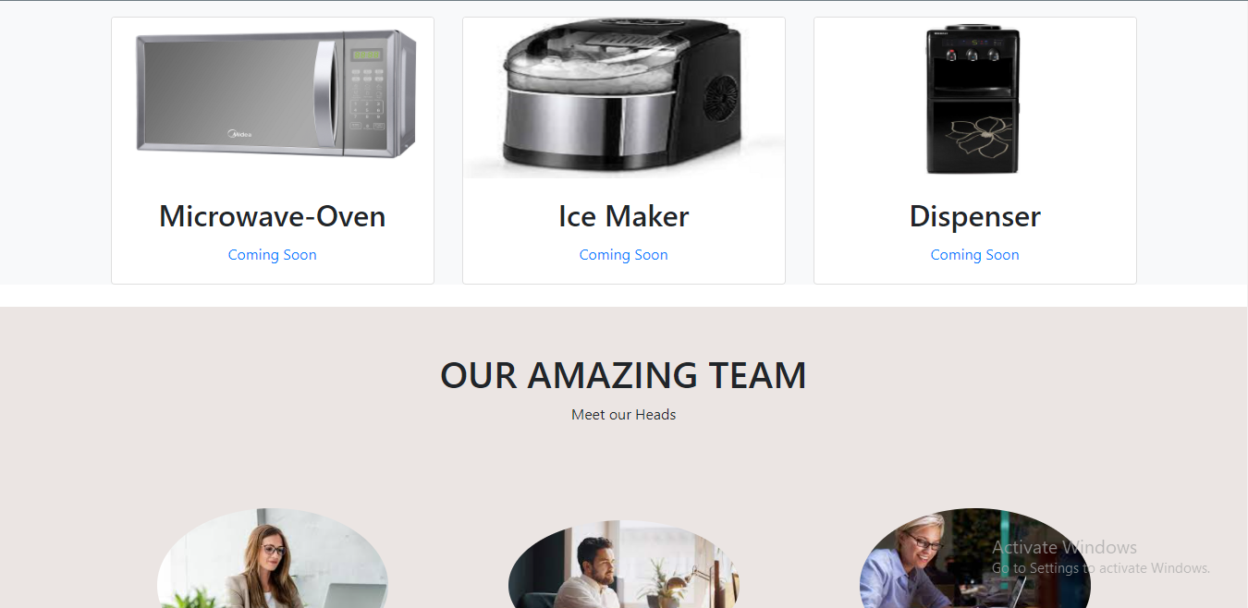

*+

**Home**



**Home**

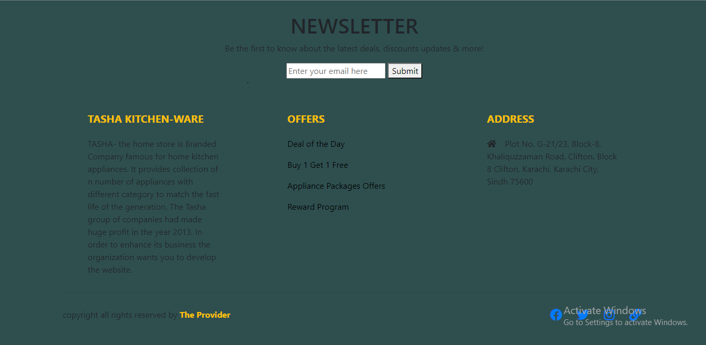

**Cooking Pots**

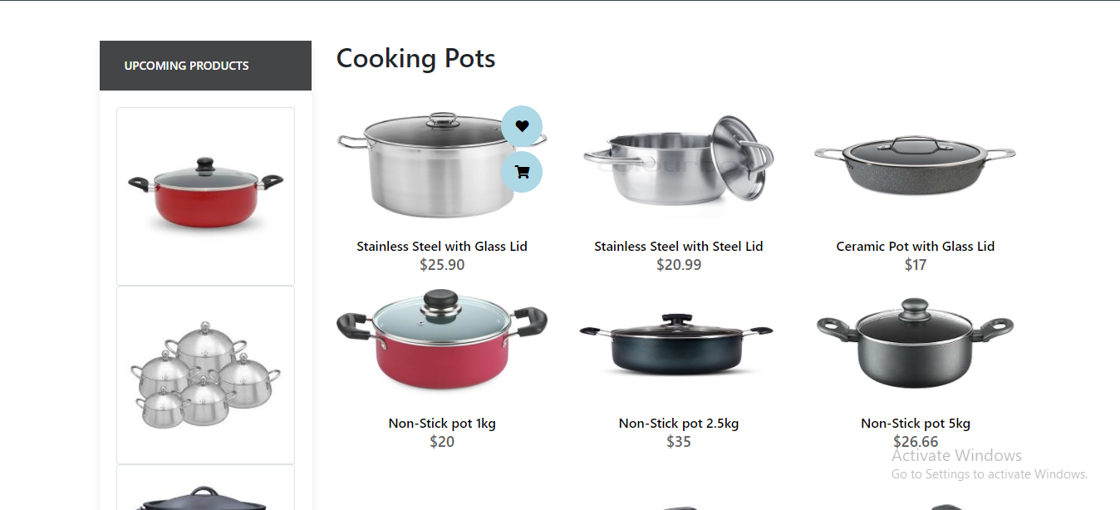

**Cooking Pots**

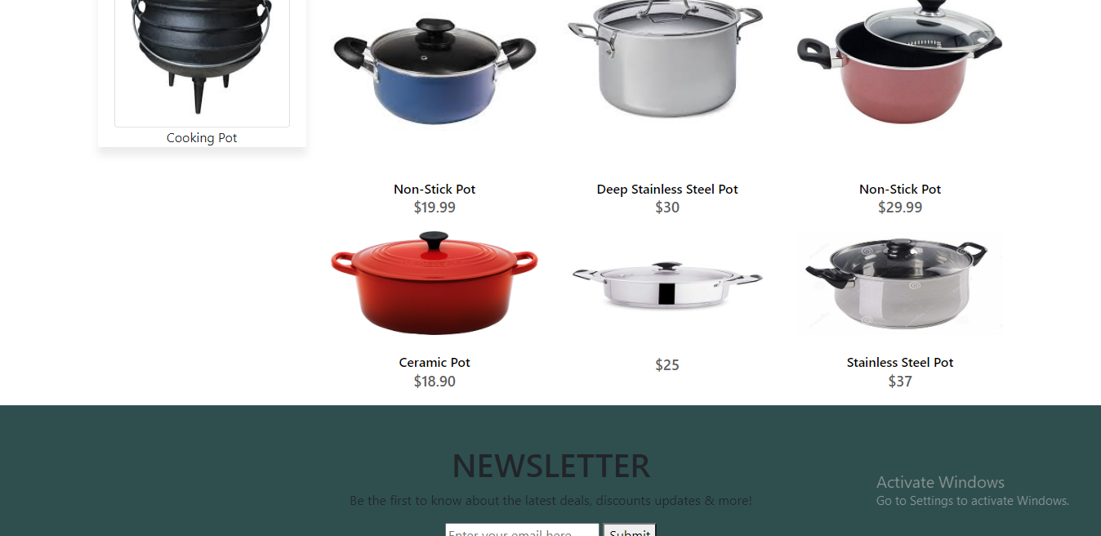

**Cooking Pots**



**Frying Pans**

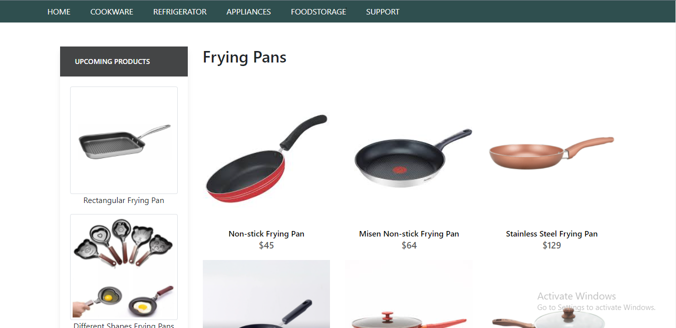

Frying Pans

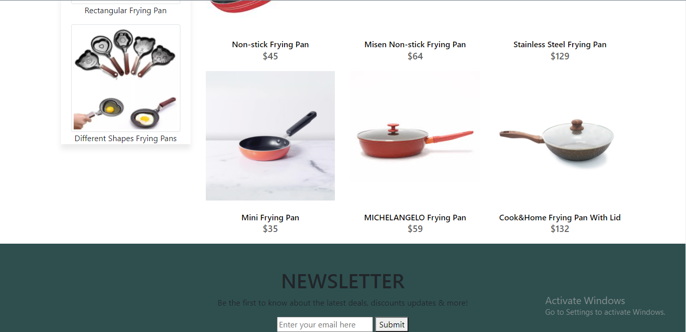

**Frying Pans**



**Cookware Sets**

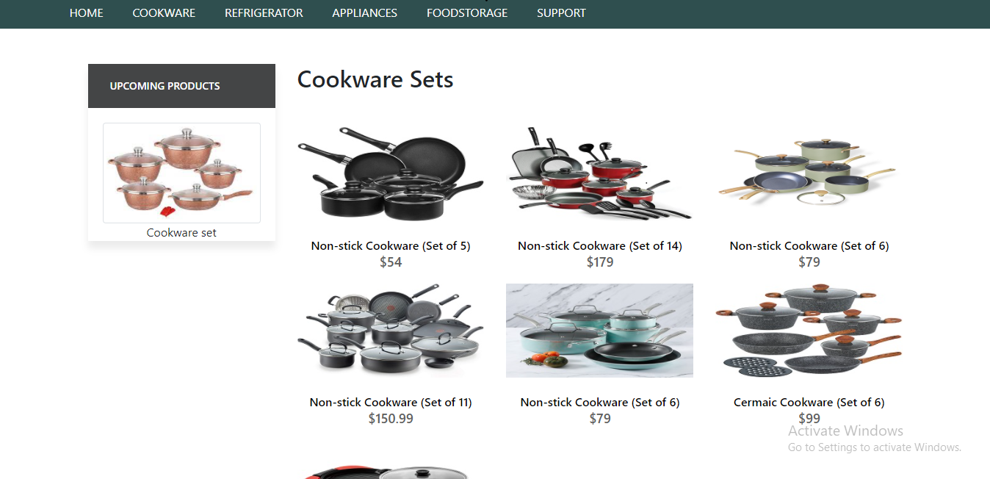

**Cookware Sets**

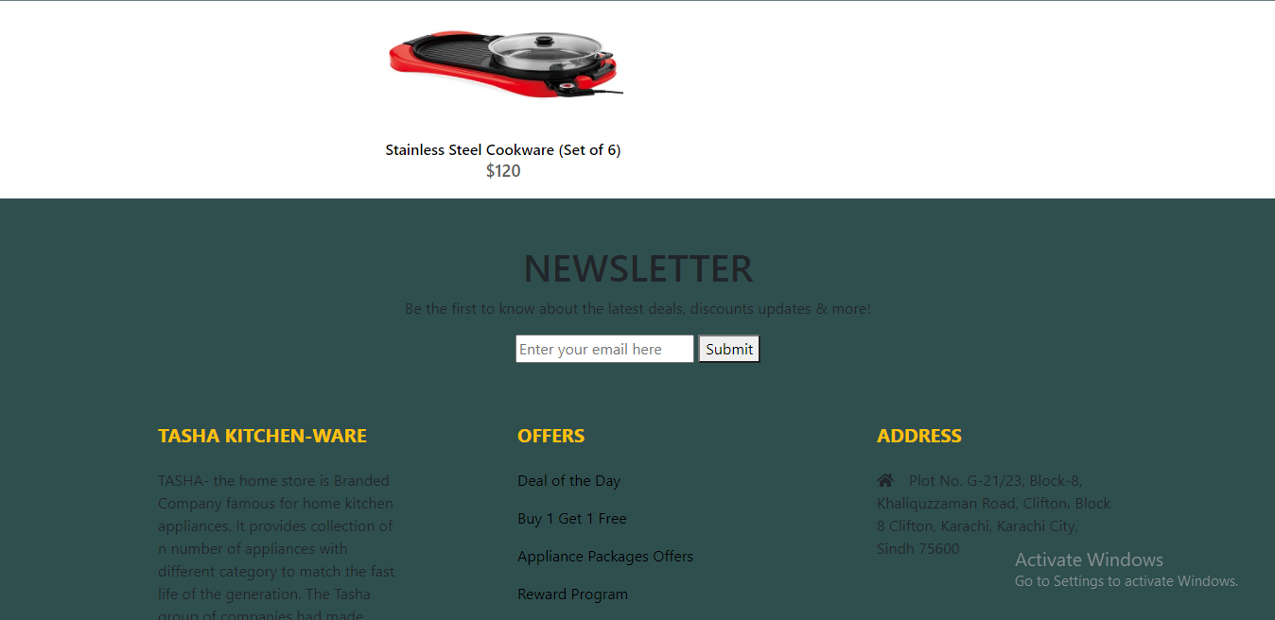

Cookware Sets



**Egg Poachers**

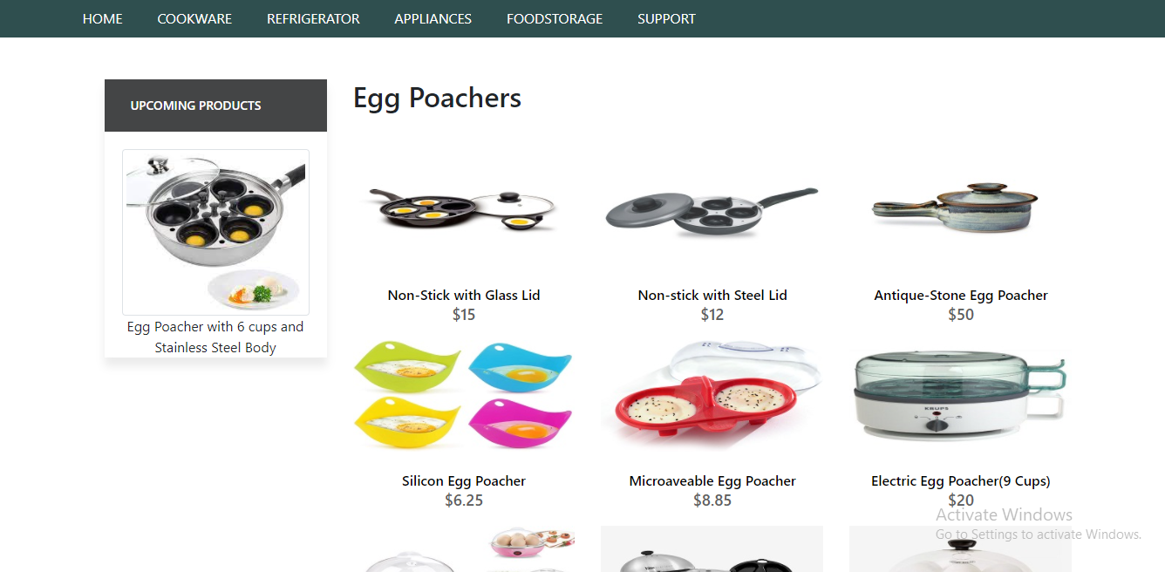

**Egg Poachers**

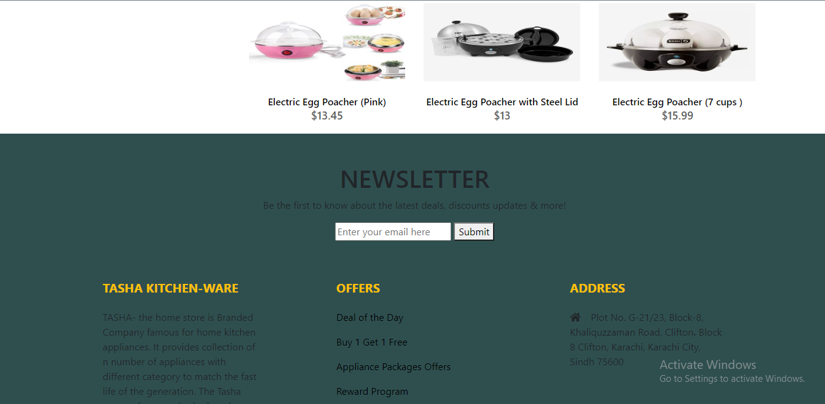

**Egg Poacher**



**Grill Pans**

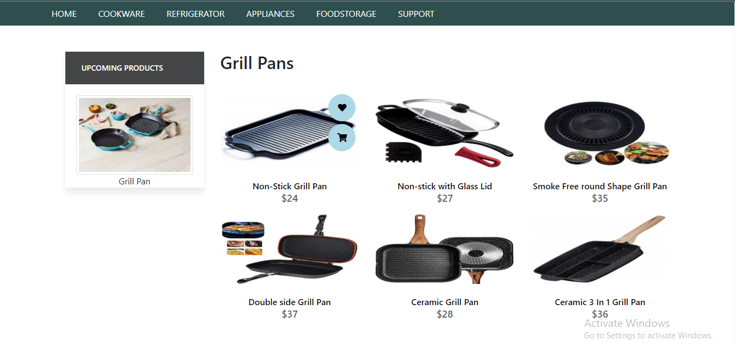

**Grill Pans**

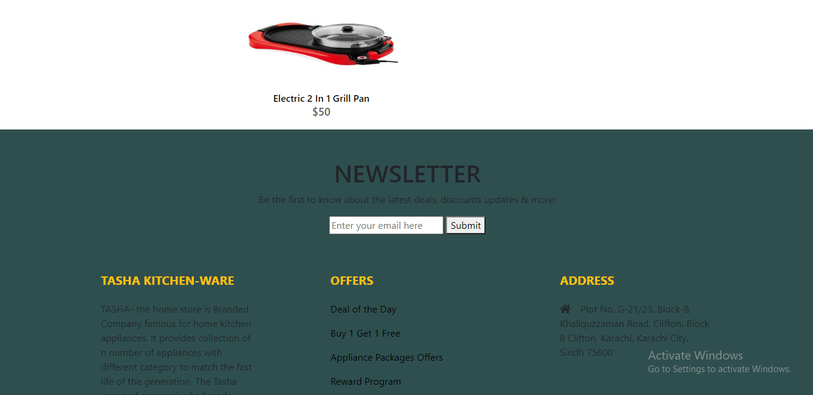 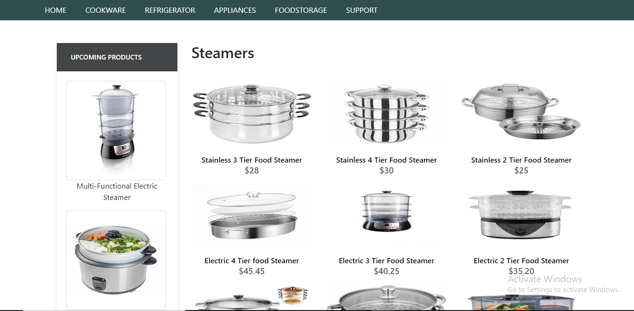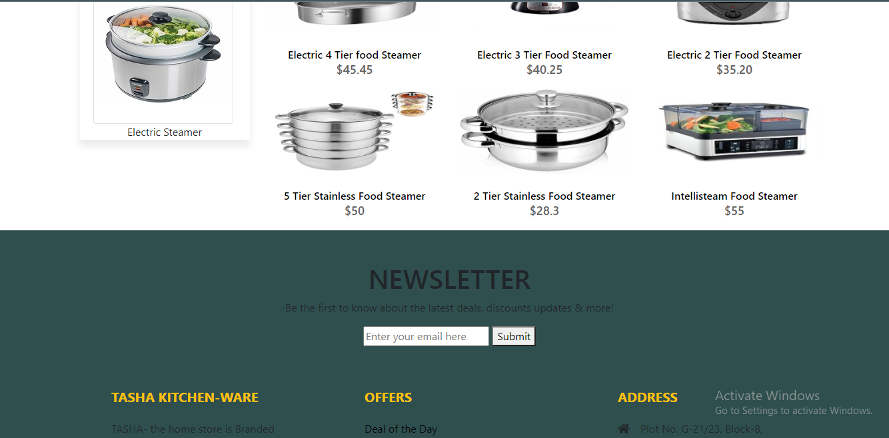

**Grill Pans**

**Steamers**

**Steamers**

**Steamers**

**Refrigerator**

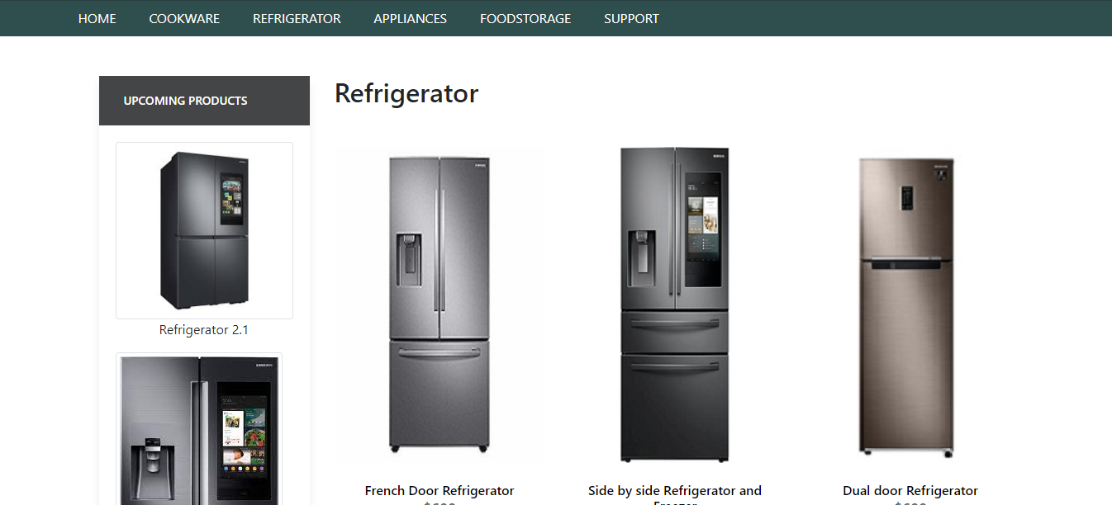

**Refrigerator**

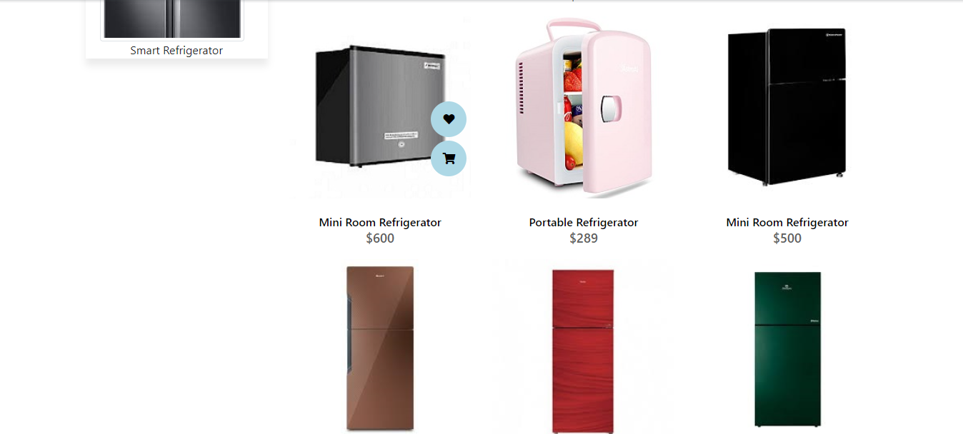

**Refrigerator**

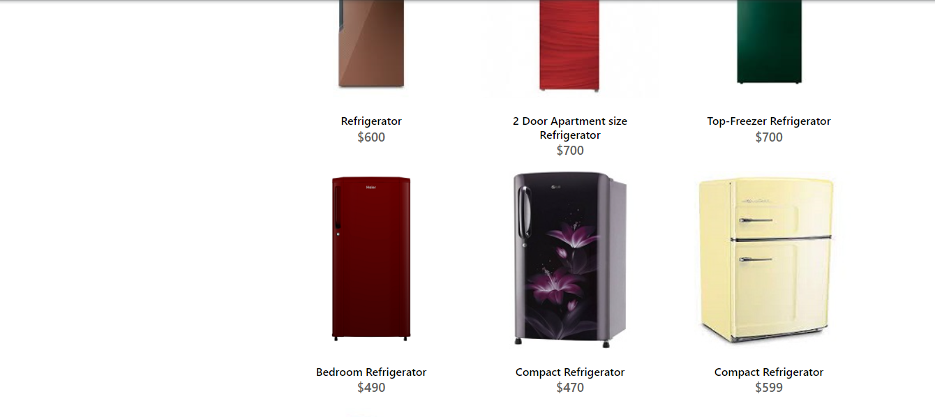

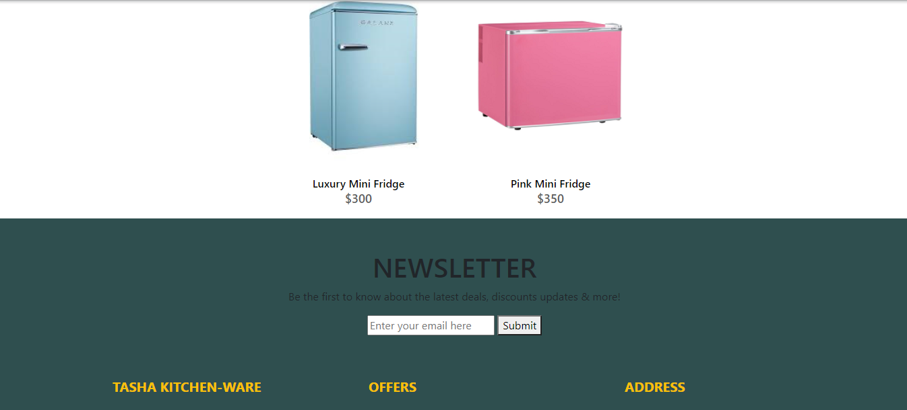

**Refrigerator**

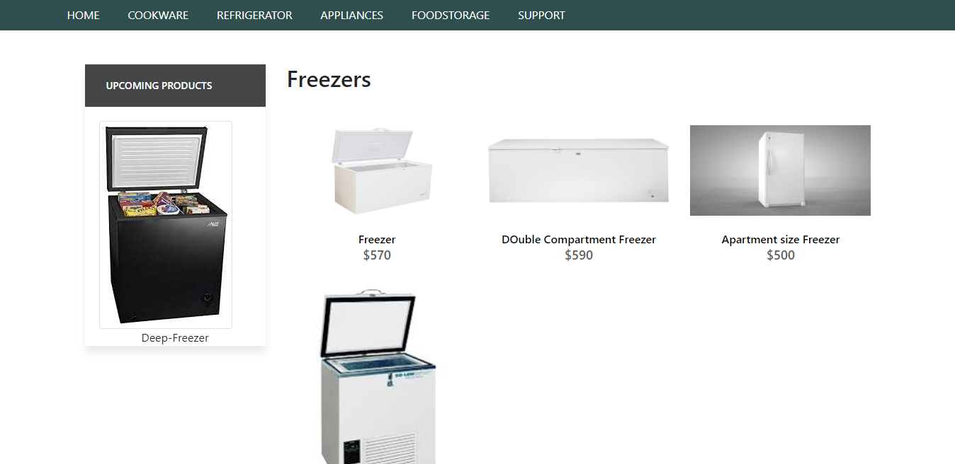

Freezers

Freezers

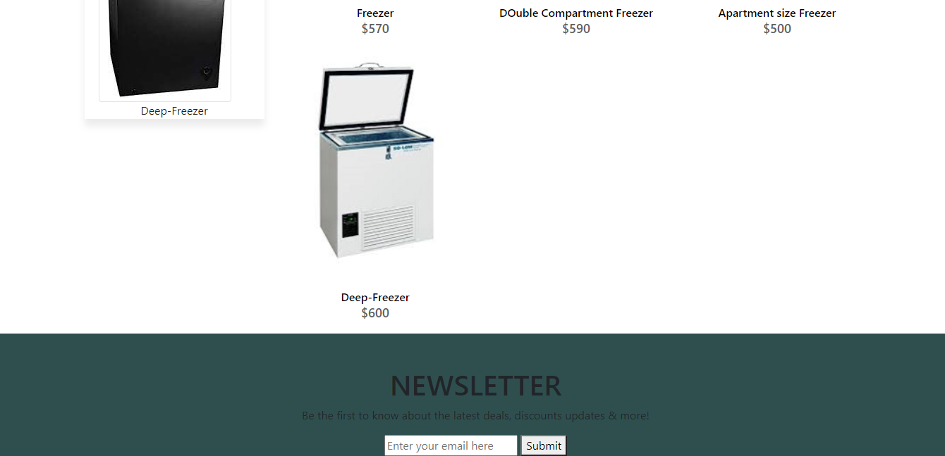

Blenders

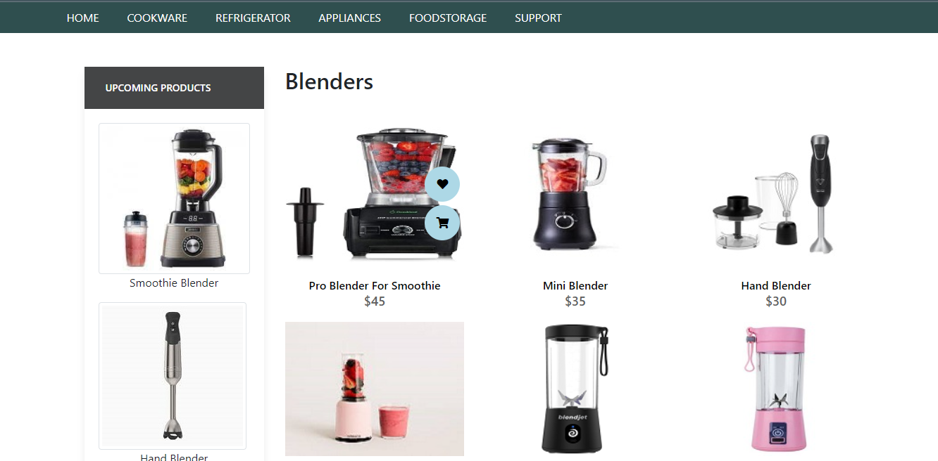

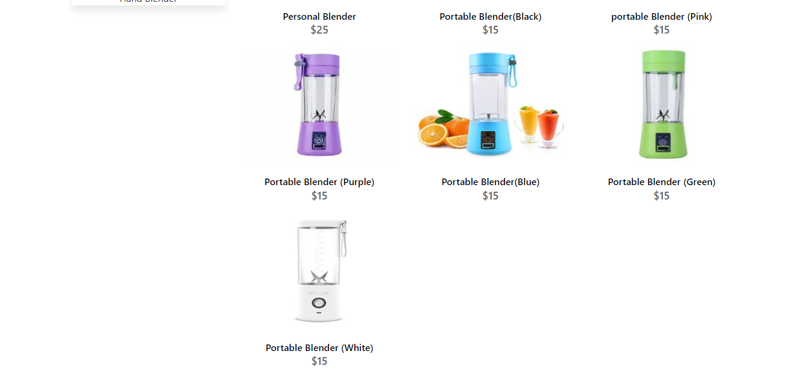

Blenders

Blenders



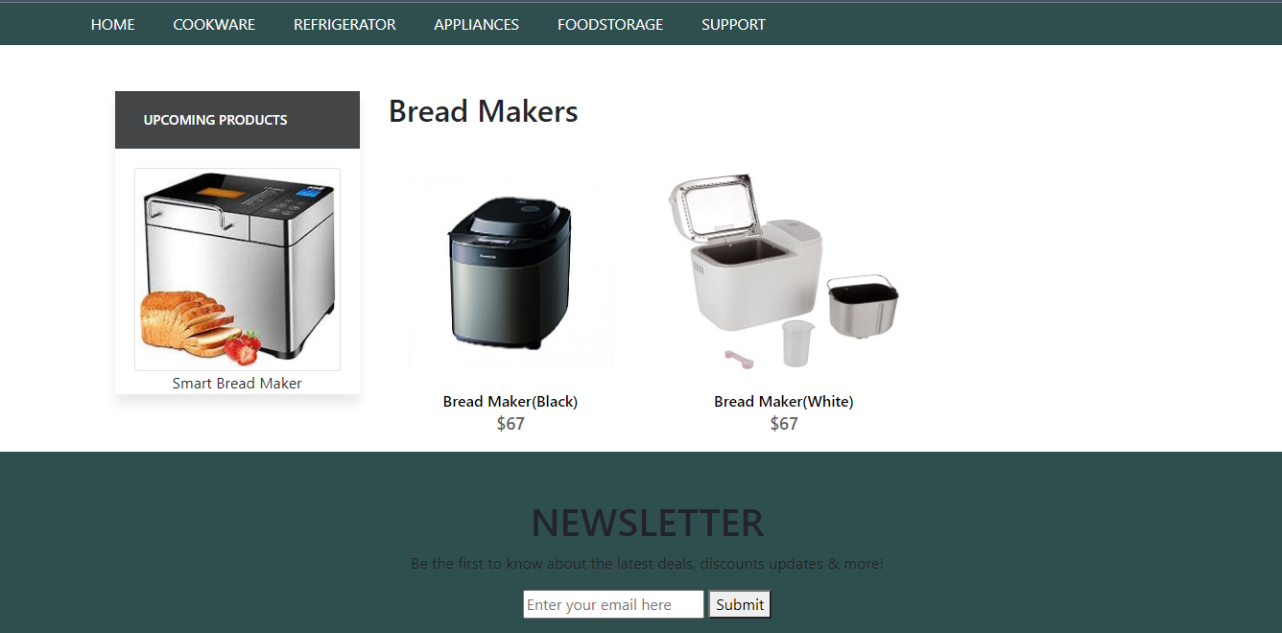

Bread Makers

Coffee Makers

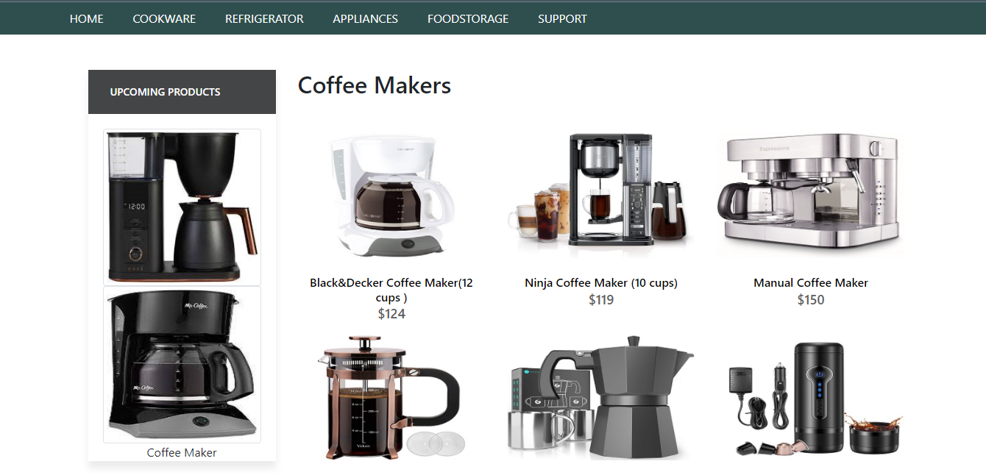

Coffee Makers

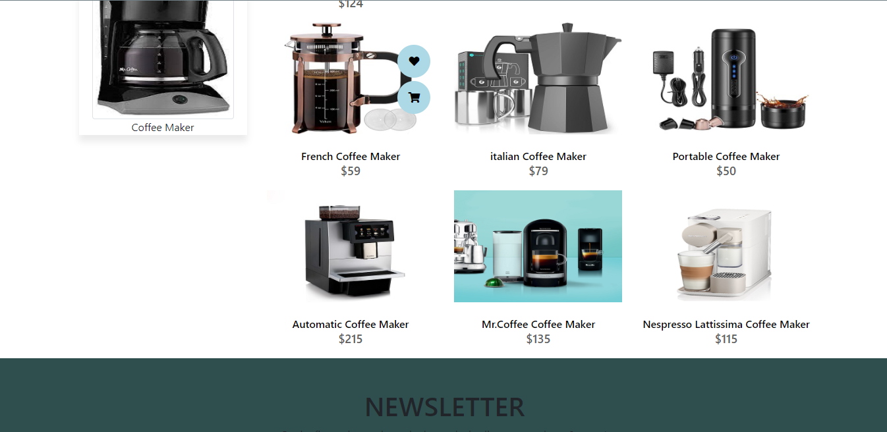

Ice-Cream and Sorbet Makers

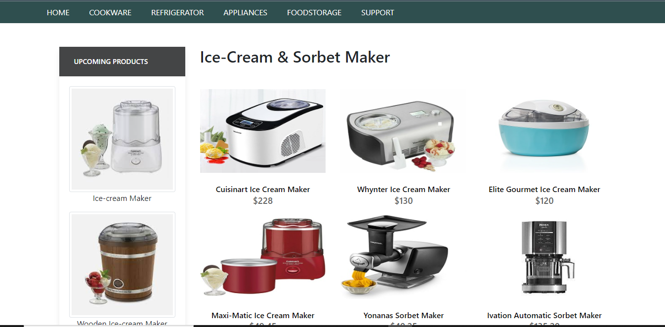



Ice-Cream and Sorbet Makers

Food Choppers

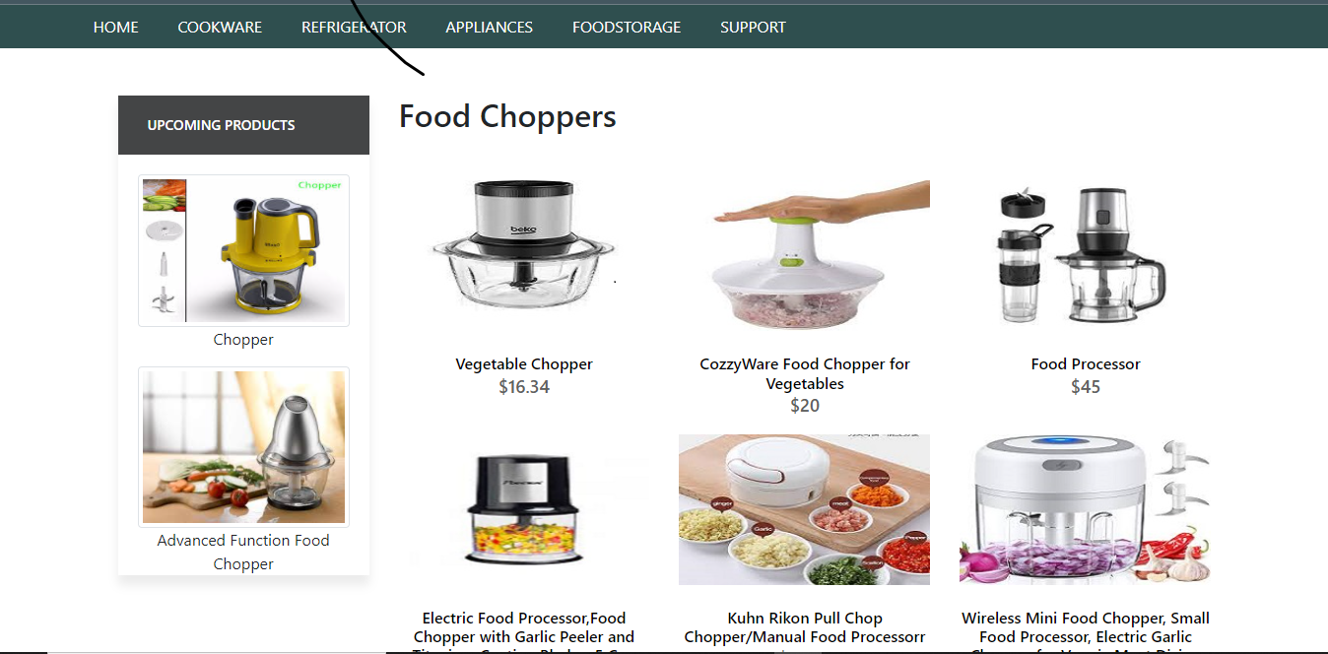

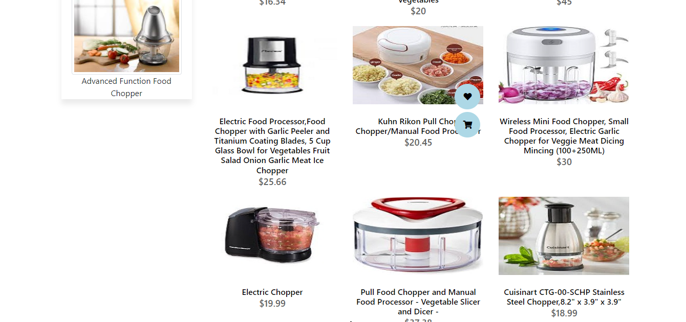

Food Choppers

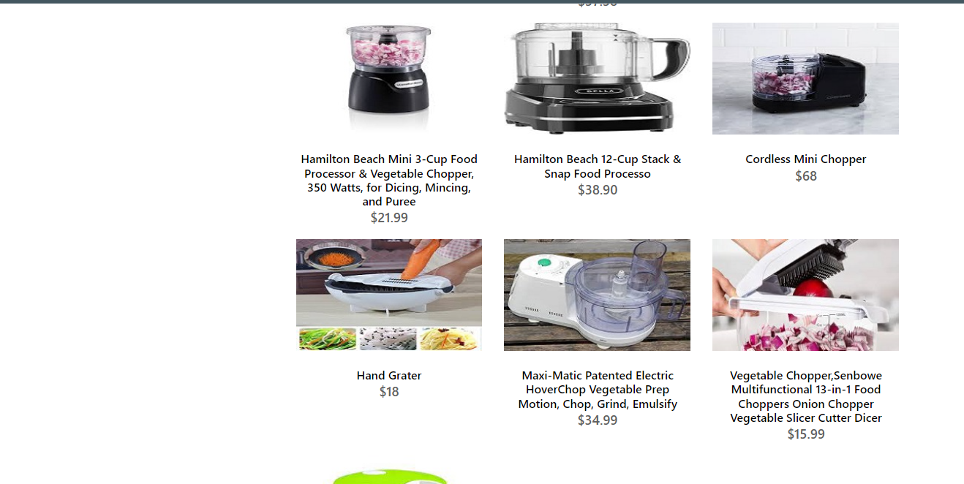

Food Choppers

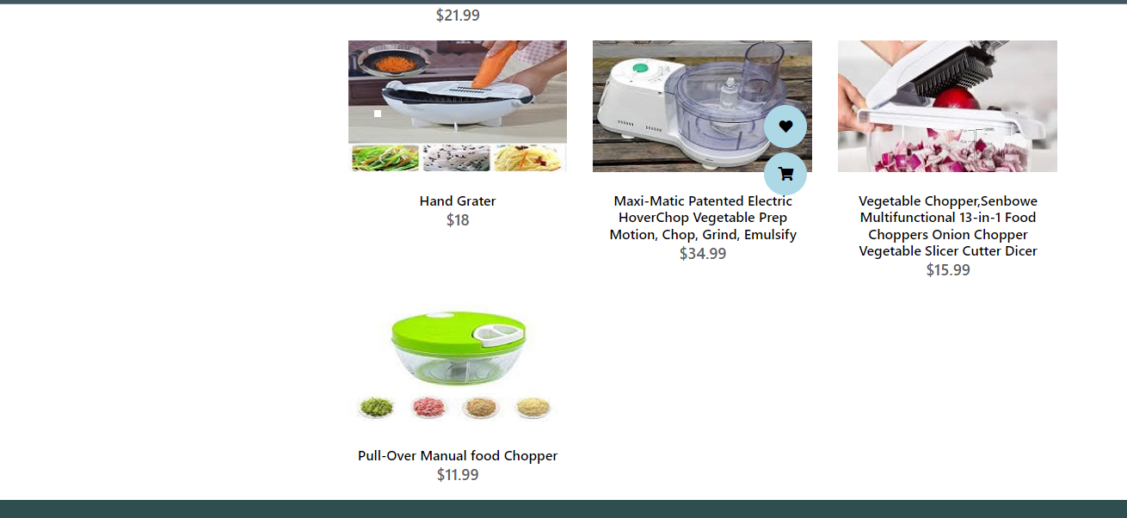

Food Choppers

**Food Choppers**



Toaster

+*-

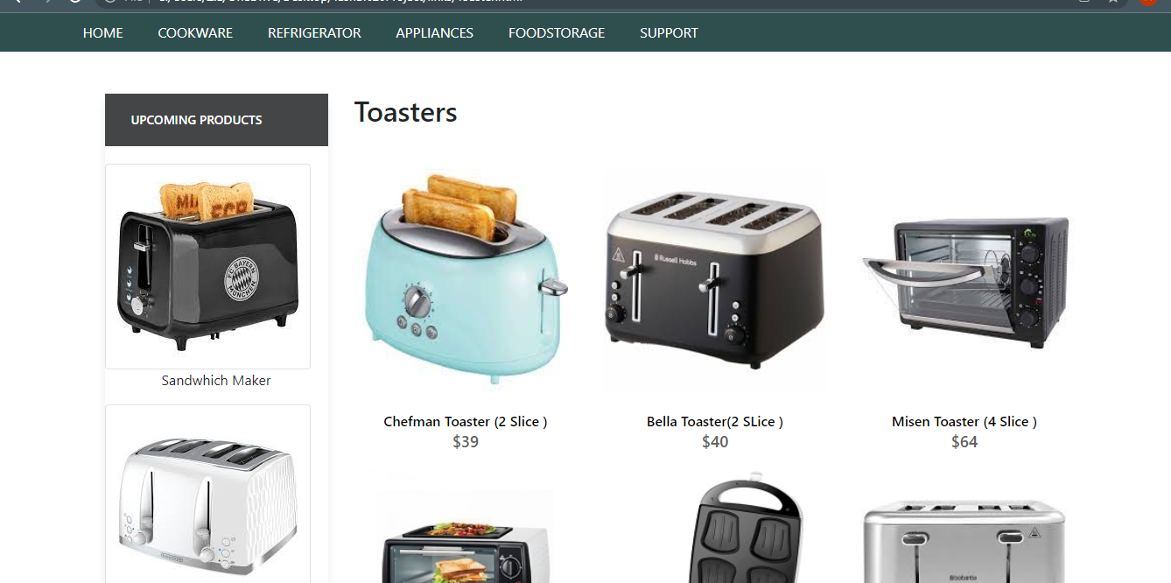

Toasters

+-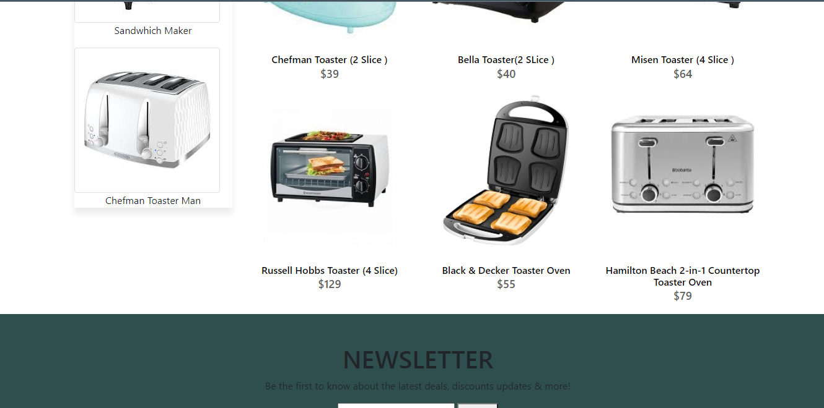

Flasks

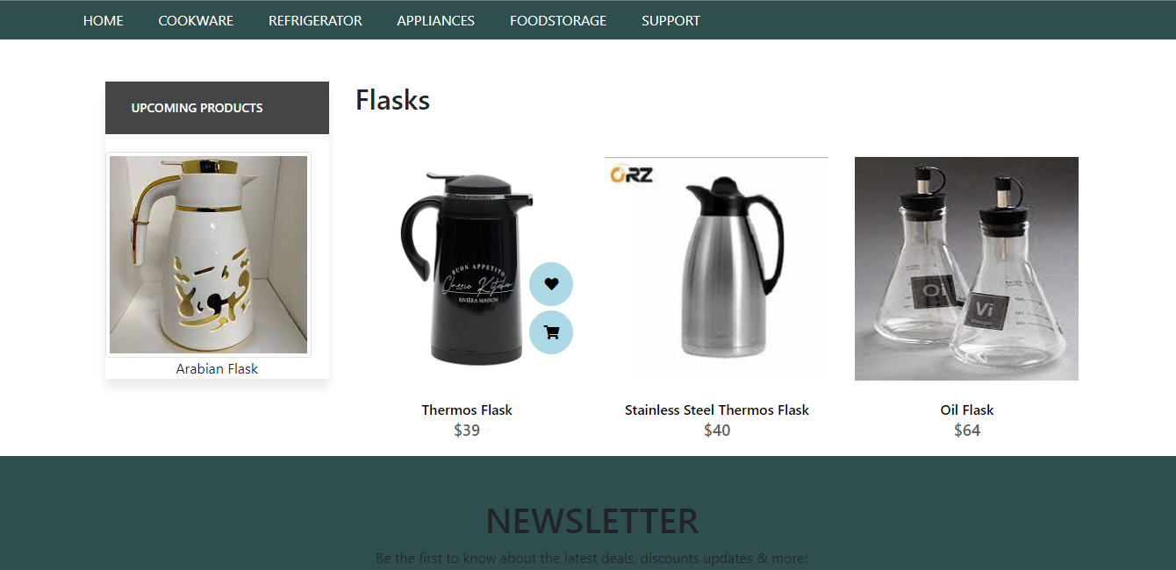

Spice Jars

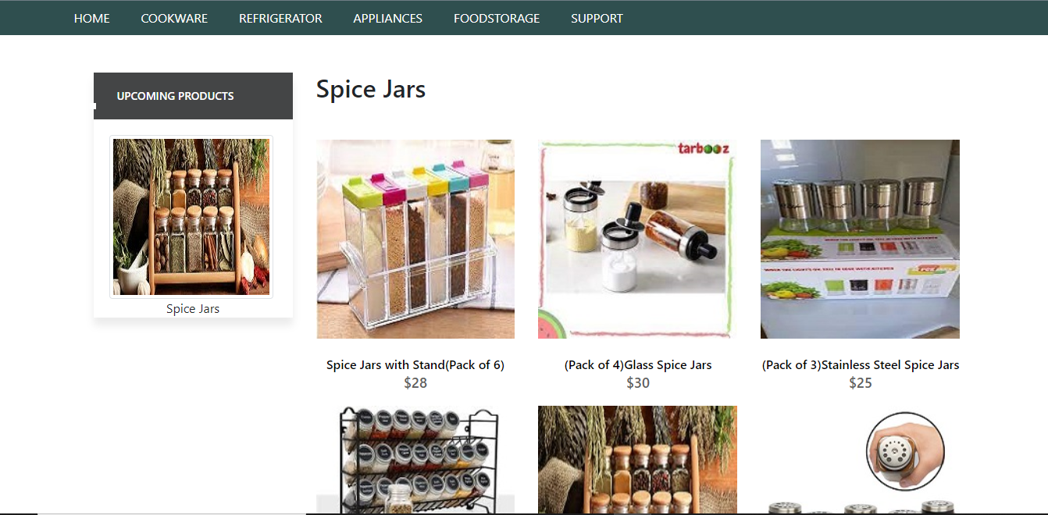

Spice Jars

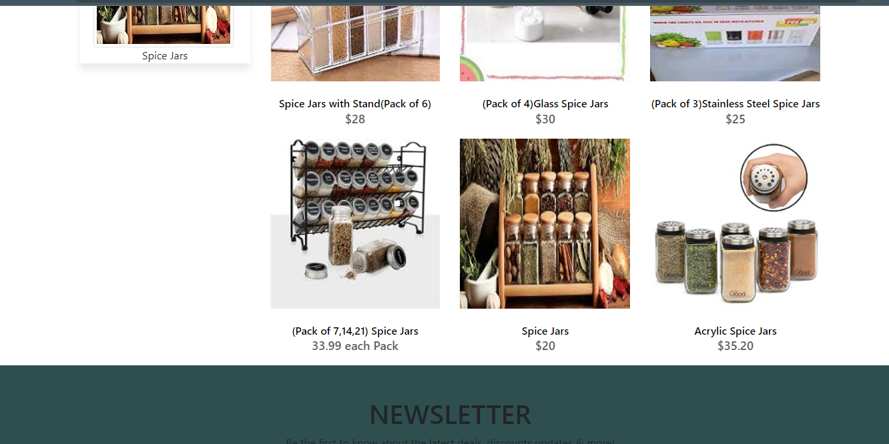

Spice Bags

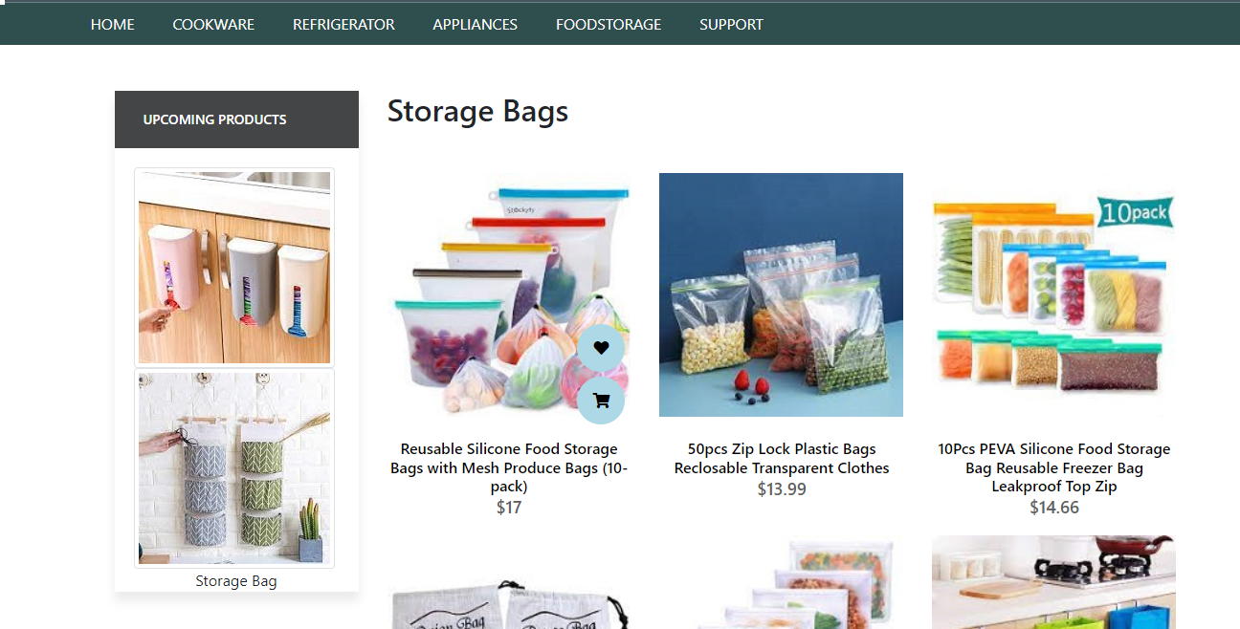

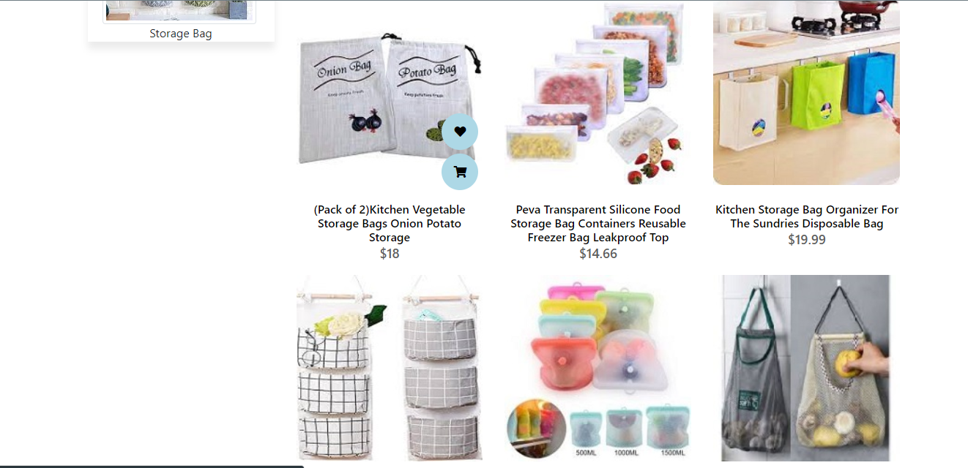

Storage Bags

Storage Bags

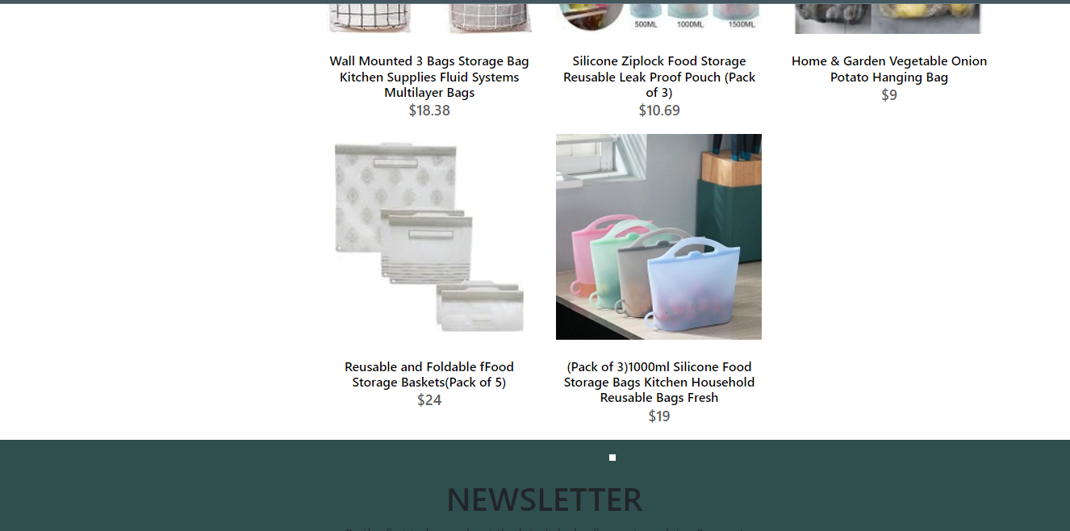

Storage Bags



Lunch Boxes

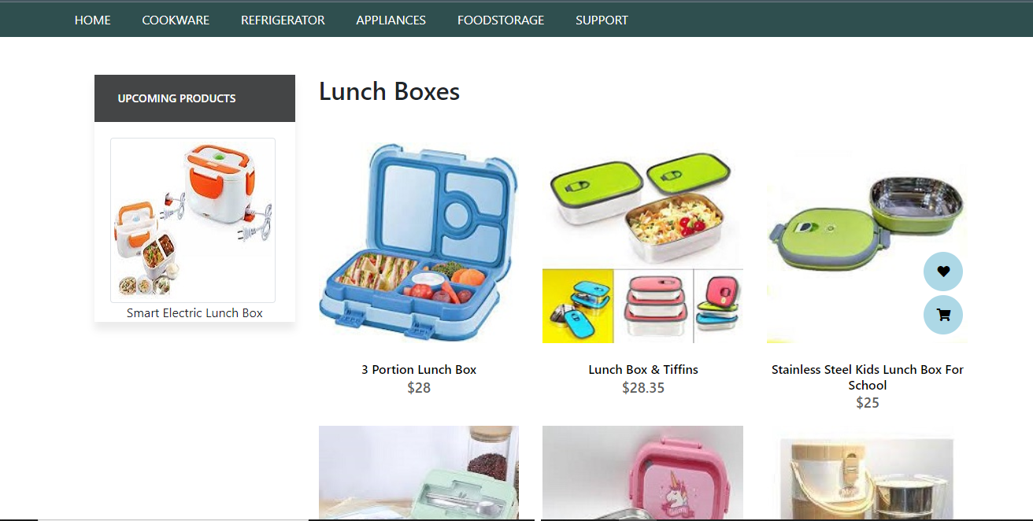

Lunch Boxes

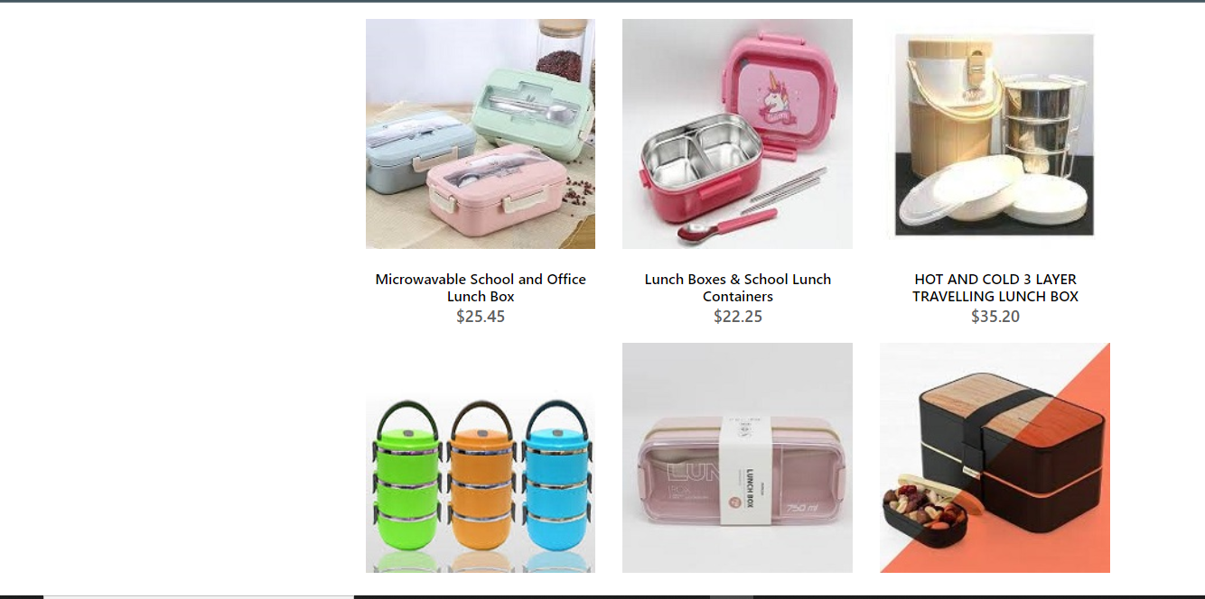

Lunch Boxes

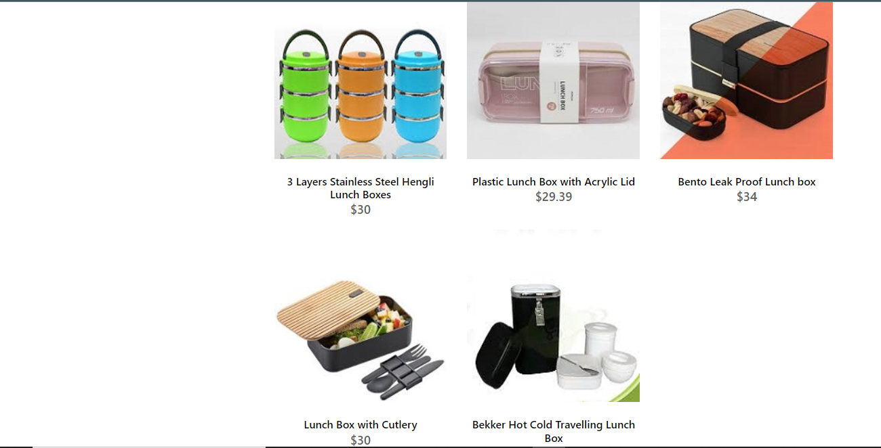

Lunch Boxes



Storage Containers

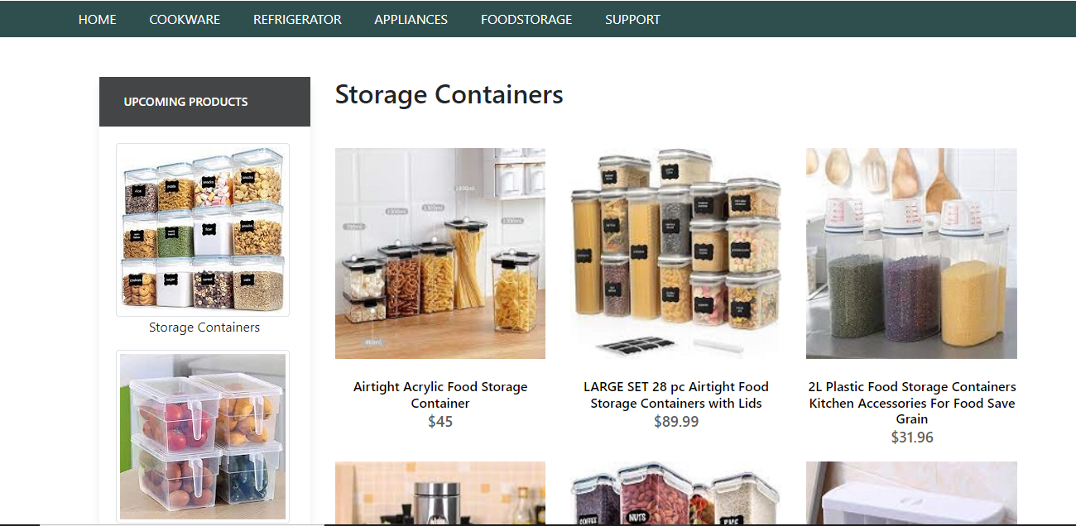

Storage Containers

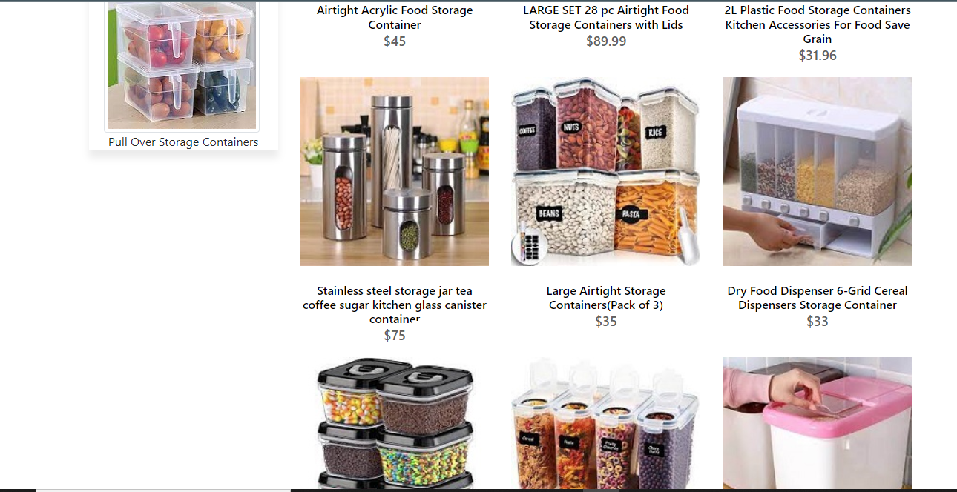

Storage Containers

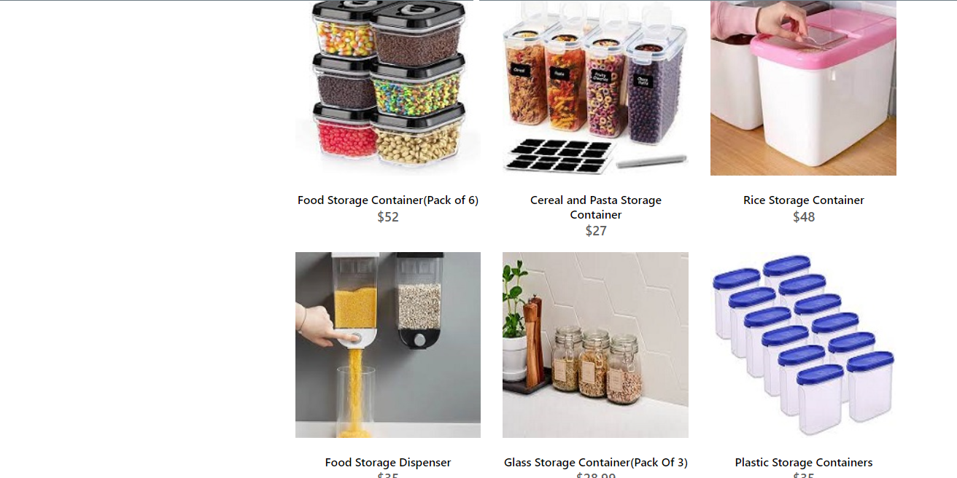

Storage Containers

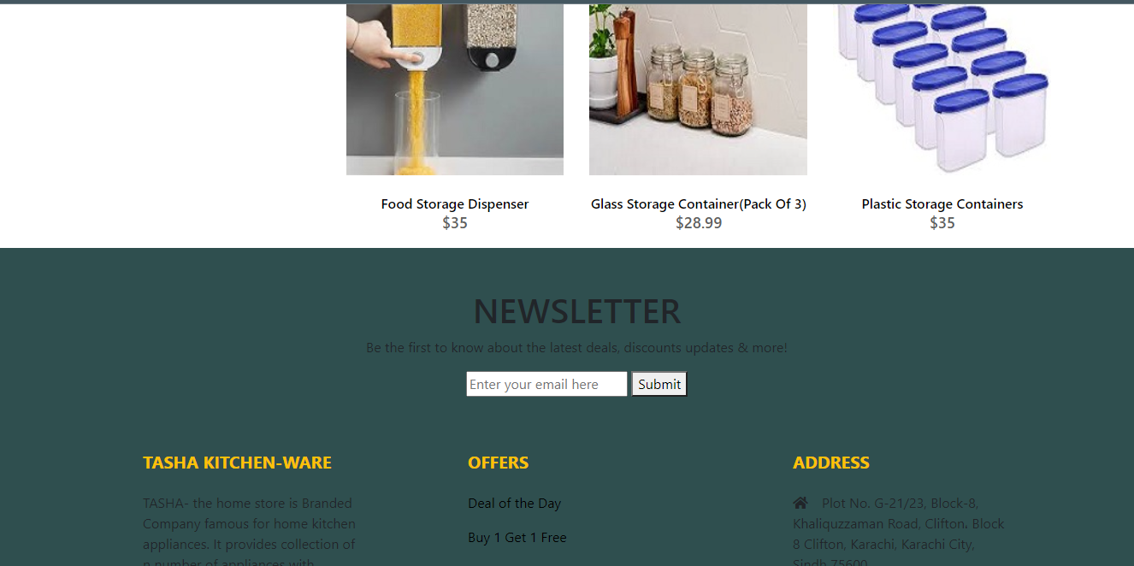

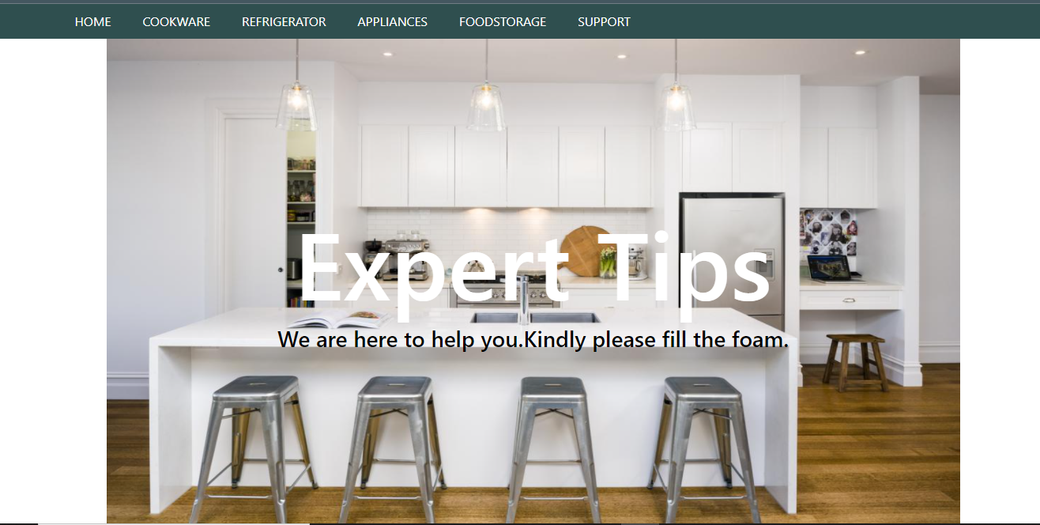

Expert Tips



Expert Tips

/’

Expert Tips

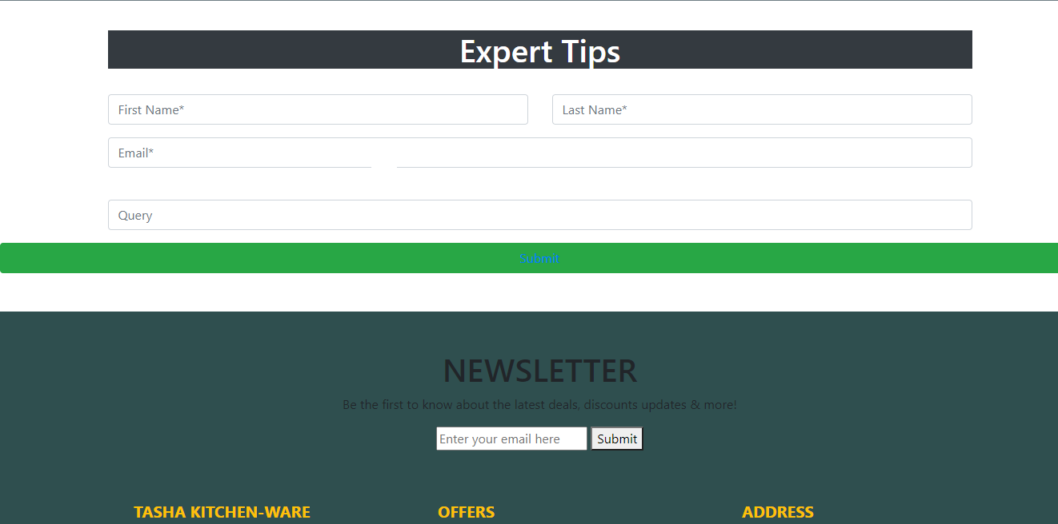

Expert Tips

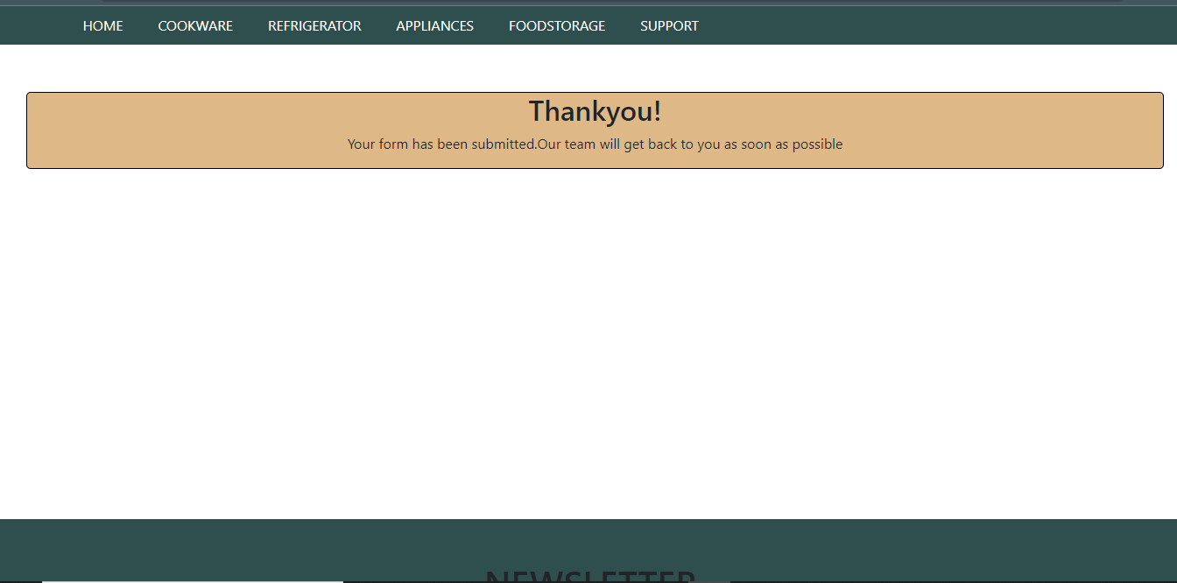

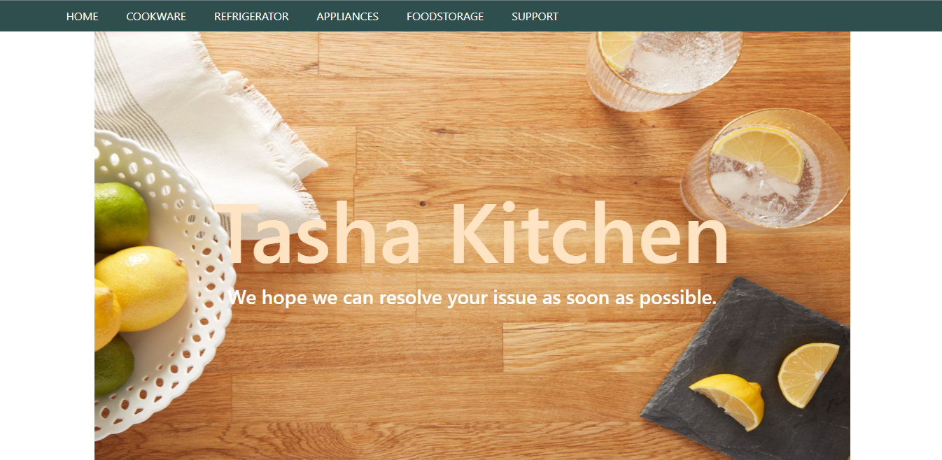

Register Complain

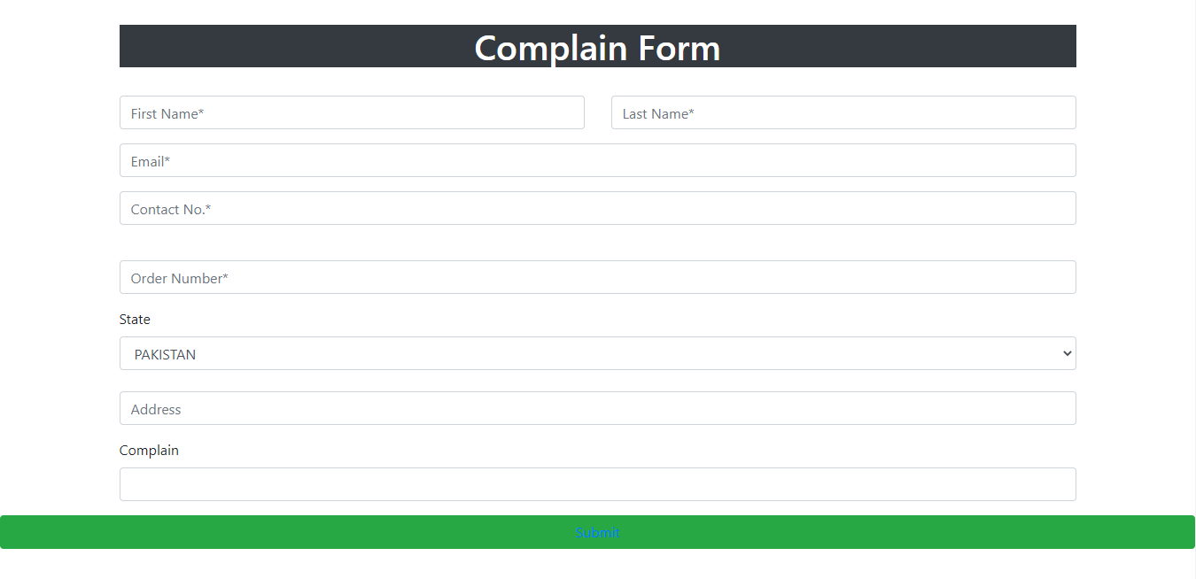

Register Complain

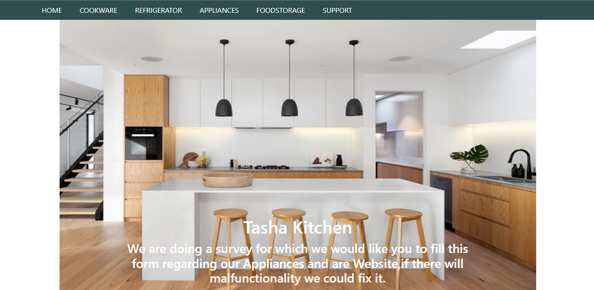

Feedback Form

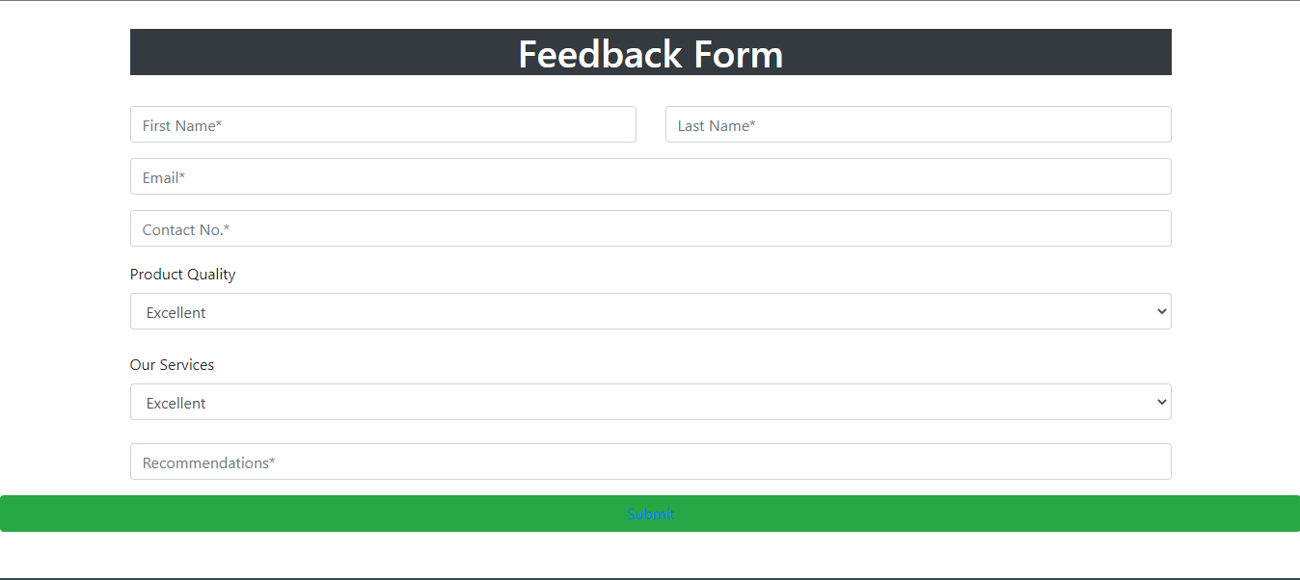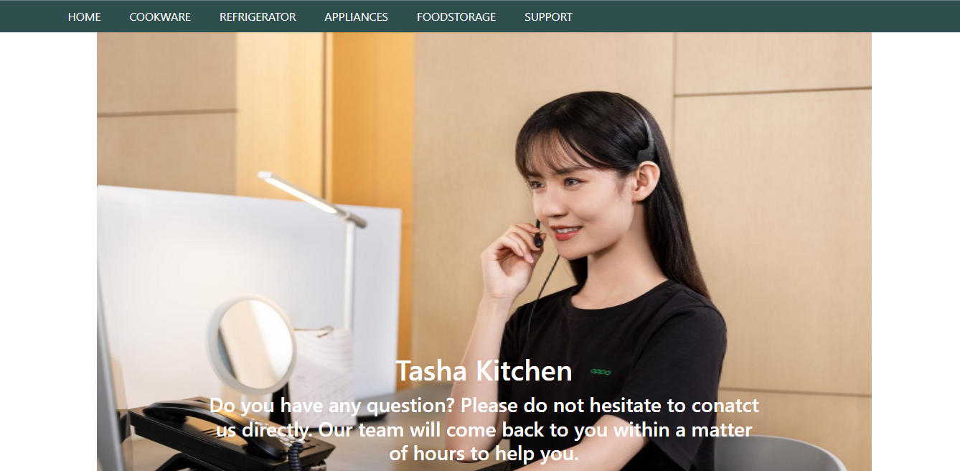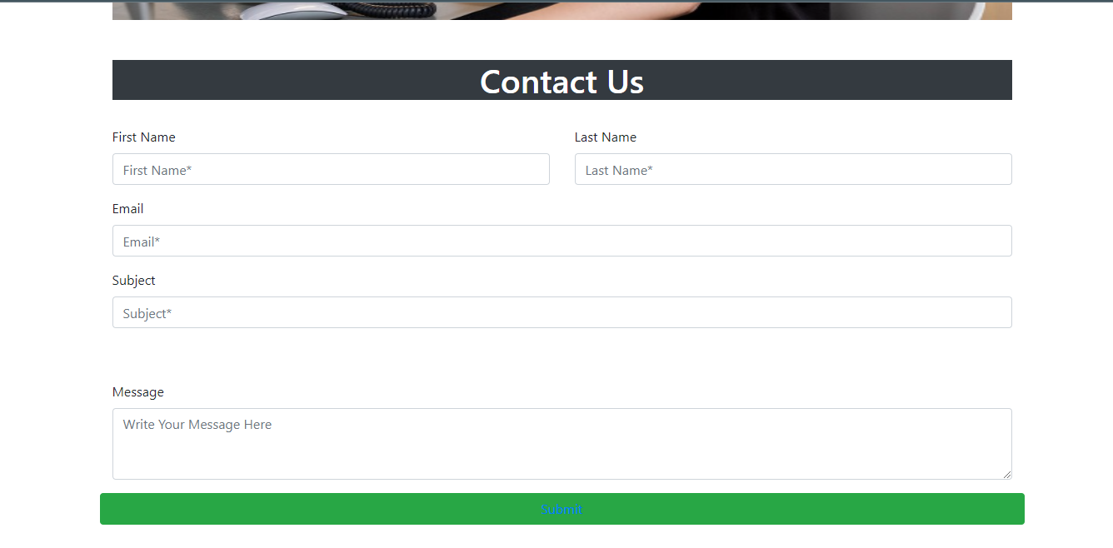

Feedback Form

Contact Us

Contact Us